HR ATTRITION DASHBOARD
--------------------------------------------------------------------------------------------------------------------------------------
Employee Attrition Analysis using Power BI

PROJECT REPORT

SUBMITTED BY

T.SANJANI
23211A67B4

COMPUTER SCIENCE AND ENGINEERING (DATA SCIENCE)
B V RAJU INSTITUTE OF TECHNOLOGY
ACADEMIC YEAR
2025-2026


TABLE OF CONTENTS
- Abstract
- Introduction
- Project Objectives
- Dataset Description
- Data Cleaning and Transformation
- DAX Measures Used
- Dashboard Development
- Overview Dashboard Analysis
- Employee Insights Dashboard Analysis
- Key Findings
- Conclusion
- References

1.ABSTRACT
The HR Attrition Dashboard is a data visualization project developed using Microsoft Power BI to analyze employee attrition patterns within an organization. Employee attrition is an important factor that affects organizational productivity, employee retention, and workforce planning.
This project utilizes HR employee data containing information such as age, department, job role, salary, gender, education field, marital status, overtime status, and attrition. The data was cleaned and transformed using Power Query, and interactive dashboards were created to provide meaningful insights.
The dashboard enables users to analyze attrition across different departments, age groups, job roles, salary ranges, and employee demographics. Key performance indicators (KPIs) such as Total Employees, Total Attrition, Average Salary, and Attrition Rate are included to support decision-making.
The project demonstrates how business intelligence tools can be used to convert raw data into actionable insights, helping organizations identify factors contributing to employee turnover and improve employee retention strategies.

2.INTRODUCTION
Human Resource (HR) Analytics is the process of collecting, analyzing, and interpreting employee-related data to support effective decision-making within an organization. HR Analytics helps organizations understand workforce trends, improve employee performance, and develop strategies for employee retention.
Employee Attrition refers to the reduction in the workforce due to employees leaving an organization voluntarily or involuntarily. High attrition rates can negatively impact organizational productivity, increase recruitment costs, and affect overall business performance. Therefore, understanding the factors contributing to employee attrition is essential for effective workforce management.
In today's data-driven environment, organizations use Business Intelligence (BI) tools to analyze employee data and identify patterns that influence employee turnover. Microsoft Power BI is one of the most widely used BI tools for creating interactive dashboards and visual reports. It enables users to transform raw data into meaningful insights through data visualization techniques.
This project focuses on developing an HR Attrition Dashboard using Microsoft Power BI. The dashboard provides a comprehensive analysis of employee attrition based on factors such as department, age group, job role, salary range, overtime, gender, education field, marital status, and job satisfaction. Interactive visualizations and Key Performance Indicators (KPIs) are used to help users identify important trends and support data-driven decision-making.
The project demonstrates how Power BI can be utilized to analyze HR data effectively and provide actionable insights that help organizations improve employee retention and workforce planning.

3.PROJECT OBJECTIVES
The main objective of this project is to develop an interactive HR Attrition Dashboard using Microsoft Power BI to analyze employee attrition patterns and support data-driven decision-making.
Specific objectives of the project are:
- To analyze employee attrition trends within the organization.
- To identify departments with higher employee attrition rates.
- To study the impact of age, salary, job role, and overtime on employee attrition.
- To analyze employee demographics such as gender, education field, and marital status.
- To evaluate the relationship between job satisfaction and employee attrition.
- To calculate important Key Performance Indicators (KPIs) such as Total Employees, Total Attrition, Average Salary, and Attrition Rate.
- To create interactive dashboards with filters and visualizations for better data exploration.
- To provide meaningful insights that can help organizations improve employee retention and workforce planning.
- To demonstrate the practical application of Business Intelligence tools in HR Analytics.
- To transform raw employee data into actionable insights through effective data visualization.

4.DATASET DESCRIPTION
The dataset used in this project is an HR Attrition Dataset containing employee-related information. The dataset is used to analyze employee attrition patterns and identify factors that influence employee turnover within an organization.
The dataset consists of employee demographic details, job-related information, salary details, and performance indicators. These attributes help in understanding workforce behavior and support effective HR decision-making.
Dataset Details:
• Dataset Name: HR Attrition Dataset
• Total Records: 1470 Employees
• Total Columns: 35
• Data Type: Structured Tabular Data
• Domain: Human Resource Analytics
Important Attributes Used:
- EmployeeNumber – Unique employee identifier.
- Age – Employee age.
- Gender – Employee gender.
- Department – Department in which the employee works.
- JobRole – Employee job designation.
- MonthlyIncome – Monthly salary of the employee.
- Attrition – Indicates whether the employee left the organization (Yes/No).
- OverTime – Indicates whether the employee works overtime.
- EducationField – Employee educational background.
- MaritalStatus – Employee marital status.
- JobSatisfaction – Employee satisfaction level.
- EmployeeCount – Total employee count.
Purpose of the Dataset:
The dataset is used to identify trends and patterns associated with employee attrition. By analyzing factors such as salary, department, age group, overtime, and job satisfaction, organizations can make informed decisions to improve employee retention and workforce planning.
Software Requirements
• Microsoft Power BI Desktop
• Microsoft Excel
• Windows Operating System
Hardware Requirements
• Processor: Intel i3 or above
• RAM: 4 GB or above
• Storage: 500 MB free space

5.DATA CLEANING AND TRANSFORMATION
Data cleaning and transformation are important steps in the data analysis process. Before creating visualizations, the dataset was examined and prepared to ensure data accuracy, consistency, and usability within Power BI.
The dataset was imported into Power BI and transformed using Power Query Editor. Various preprocessing techniques were applied to make the data suitable for analysis and dashboard development.
Data Cleaning Activities Performed:
- Data Validation
  - Checked the dataset for missing values and inconsistencies.
  - Verified that employee records were complete and accurate.
- Data Type Conversion
  - Ensured that numerical columns such as Age and MonthlyIncome were assigned appropriate numeric data types.
  - Verified categorical columns such as Department, Gender, and Attrition.
- Data Transformation
  - Organized employee information into meaningful categories for analysis.
  - Prepared fields for visualization and filtering.
- Creation of Age Groups
  - Employee ages were grouped into ranges to simplify analysis.
  - Example groups:
• 18–25
• 26–35
• 36–45
• 46+
- Creation of Salary Ranges
  - Monthly income values were grouped into salary ranges using bins.
  - This enabled effective visualization of attrition patterns across different income levels.
- Data Quality Checks
  - Verified employee counts.
  - Cross-checked attrition values (Yes/No).
  - Ensured consistency across all dashboard visualizations.
Power Query Usage:
Power Query Editor was used to inspect and prepare the dataset before loading it into the Power BI data model. The transformed data was then utilized for creating KPIs, DAX measures, and interactive visualizations.
Outcome:
After data cleaning and transformation, the dataset was ready for dashboard development, enabling accurate analysis of employee attrition trends and workforce insights.

6.DAX MEASURES USED
Data Analysis Expressions (DAX) is a formula language used in Microsoft Power BI for creating custom calculations and measures. DAX measures were created in this project to calculate important HR metrics and Key Performance Indicators (KPIs).
The following measures were used in the dashboard:
- Total Employees
Purpose:
This measure calculates the total number of employees present in the dataset.
Formula Used:
DISTINCT COUNT(employees[EmployeeNumber])
Usage:
Displayed as a KPI card to show the total workforce size.

- Total Attrition
Purpose:
This measure calculates the number of employees who have left the organization.
Formula Used:
CALCULATE(
COUNT(employees[EmployeeNumber]),
employees[Attrition] = "Yes"
)
Usage:
Displayed as a KPI card to monitor employee attrition.

- Average Salary
Purpose:
This measure calculates the average monthly salary of employees.
Formula Used:
AVERAGE(employees[MonthlyIncome])
Usage:
Displayed as a KPI card to provide salary insights.

- Attrition Rate
Purpose:
This measure calculates the percentage of employees who left the organization compared to the total workforce.
Formula Used:
Attrition Rate =
DIVIDE(
CALCULATE(
COUNT(employees[EmployeeNumber]),
employees[Attrition] = "Yes"
),
COUNT(employees[EmployeeNumber])
)
Usage:
Displayed as a KPI card showing the attrition percentage.

Benefits of DAX Measures
• Enable dynamic calculations.
• Improve dashboard interactivity.
• Provide real-time KPI monitoring.
• Support business decision-making through meaningful metrics.
These measures helped transform raw employee data into actionable HR insights and enhanced the analytical capabilities of the dashboard.

7.DASHBOARD DEVELOPMENT
The HR Attrition Dashboard was developed using Microsoft Power BI to provide an interactive and visually appealing platform for analyzing employee attrition trends. The dashboard was designed to transform raw employee data into meaningful insights that can support HR decision-making.
Power BI was selected because of its powerful data visualization capabilities, interactive filtering options, and support for advanced calculations through DAX measures.
Dashboard Design Process
- Data Import
The HR Attrition dataset was imported into Power BI and loaded into the data model for analysis.
- Data Preparation
The dataset was cleaned and transformed using Power Query Editor. Age groups and salary ranges were created to improve data visualization and interpretation.
- KPI Development
Key Performance Indicators (KPIs) were created to provide a quick overview of important HR metrics, including:
• Total Employees
• Total Attrition
• Average Salary
• Attrition Rate
- Visualization Development
Various Power BI visualizations were used to analyze employee attrition from different perspectives:
• Bar Charts
• Pie Charts
• Card Visuals
• Slicers
• Interactive Filters
- Interactive Features
Department slicers were implemented to allow users to dynamically filter dashboard data and explore specific departments.
- Dashboard Pages
The dashboard was divided into two sections:
A. HR Overview Dashboard
This page provides a high-level view of employee attrition trends, including:
• Attrition by Age Group
• Attrition by Job Role
• Attrition by Department
• Attrition by Salary Range
• Attrition vs Overtime
B. Employee Insights Dashboard
This page provides detailed employee-related insights, including:
• Gender Analysis
• Education Field Analysis
• Marital Status Analysis
• Job Satisfaction Analysis
• KPI Metrics
- Theme and Formatting
A professional blue-themed design was applied to maintain consistency and improve dashboard readability. Borders, shadows, titles, and visual alignment were used to enhance presentation quality.
Outcome
The completed dashboard enables users to interactively analyze employee attrition patterns and identify key factors affecting employee retention. The dashboard provides valuable insights that can help organizations improve workforce management and retention strategies.
8.HR OVERVIEW DASHBOARD ANALYSIS
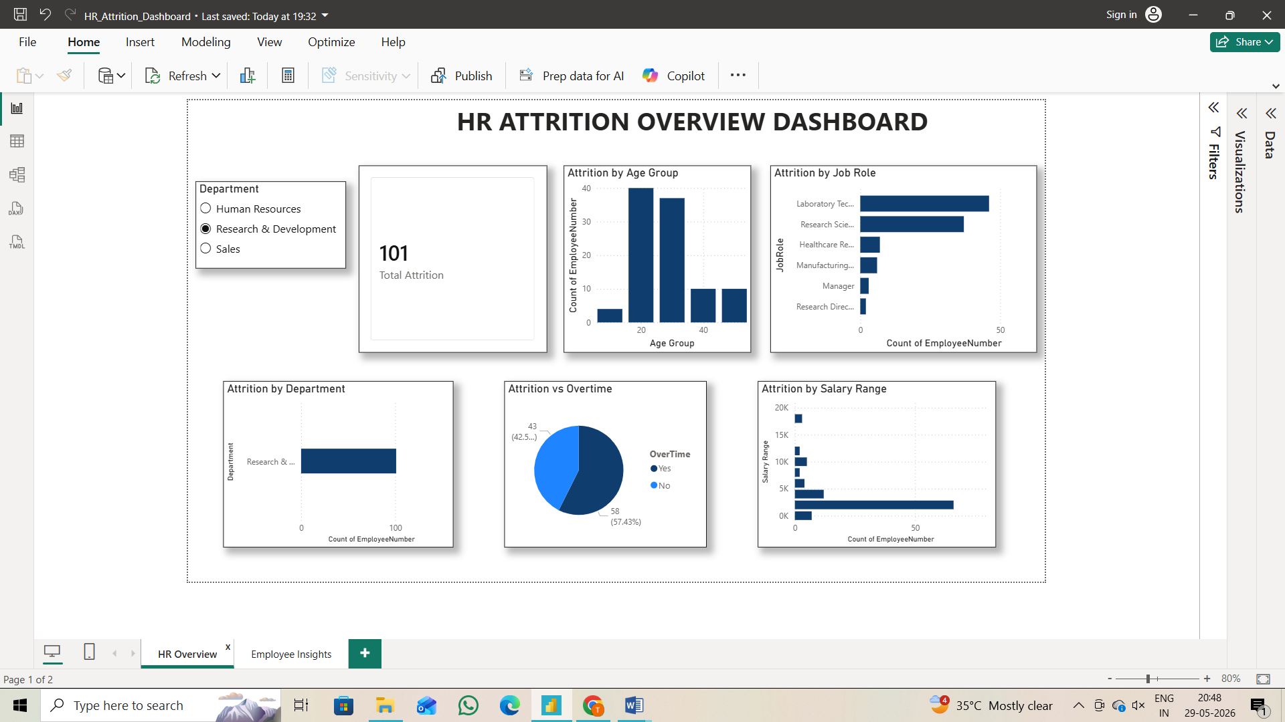

The HR Overview Dashboard provides a high-level analysis of employee attrition trends within the organization. The dashboard helps identify factors that contribute to employee turnover and enables users to explore attrition patterns through interactive visualizations.
Dashboard Components
• Total Attrition KPI
• Department Slicer
• Attrition by Age Group
• Attrition by Job Role
• Attrition by Department
• Attrition by Salary Range
• Attrition vs Overtime
Key Insights
- Attrition by Age Group
The age group analysis indicates that younger employees contribute significantly to employee attrition. Employees within the early and mid-career stages show a higher tendency to leave the organization compared to older employees.
- Attrition by Job Role
The dashboard highlights job roles that experience higher employee turnover. Certain operational and sales-related roles show relatively higher attrition levels, indicating potential retention challenges.
- Attrition by Department
Department-wise analysis reveals differences in employee attrition across organizational departments. Research & Development and Sales departments account for a significant portion of total attrition.
- Attrition by Salary Range
Salary range analysis helps understand the relationship between employee compensation and attrition. Lower salary ranges tend to experience higher attrition compared to higher salary ranges.
- Attrition vs Overtime
The overtime analysis indicates that employees working overtime show a higher likelihood of leaving the organization. This suggests that workload and work-life balance may influence employee retention.
Benefits of the Dashboard
• Provides a quick overview of attrition trends.
• Supports data-driven HR decision-making.
• Helps identify departments and employee groups requiring attention.
• Enables interactive exploration through department filtering.
Overall, the HR Overview Dashboard serves as an effective tool for monitoring workforce trends and understanding the major factors contributing to employee attrition.

9.EMPLOYEE INSIGHTS DASHBOARD ANALYSIS
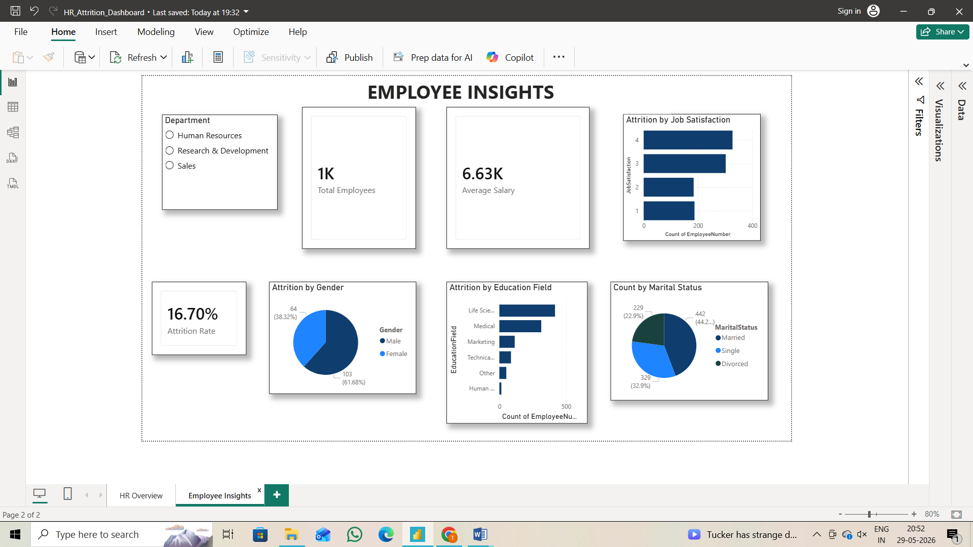

The Employee Insights Dashboard provides detailed information about employee demographics, satisfaction levels, and workforce characteristics. This dashboard helps organizations understand employee behavior and identify factors that may influence attrition and retention.
Dashboard Components
• Total Employees KPI
• Average Salary KPI
• Attrition Rate KPI
• Gender Analysis
• Education Field Analysis
• Marital Status Analysis
• Job Satisfaction Analysis
• Department Slicer
Key Insights
- Total Employees
The Total Employees KPI displays the overall workforce size available in the dataset. This metric serves as the baseline for workforce analysis.
- Average Salary
The Average Salary KPI provides information about the average monthly income of employees. It helps organizations understand compensation trends across the workforce.
- Attrition Rate
The Attrition Rate KPI measures the percentage of employees who left the organization. This KPI is important for evaluating employee retention performance.
- Gender Analysis
The gender distribution visualization provides insights into workforce composition and attrition patterns among male and female employees.
- Education Field Analysis
The education field analysis helps identify employee distribution across different educational backgrounds. It enables organizations to understand workforce diversity and specialization.
- Marital Status Analysis
The marital status visualization shows employee distribution based on marital categories such as Single, Married, and Divorced. This analysis provides additional demographic insights.
- Job Satisfaction Analysis
Job satisfaction is an important factor influencing employee retention. The dashboard helps identify satisfaction levels among employees and supports understanding of employee engagement patterns.
Benefits of the Dashboard
• Provides detailed workforce insights.
• Supports employee demographic analysis.
• Helps monitor attrition-related indicators.
• Assists HR teams in workforce planning and retention strategies.
• Enables interactive analysis through department-level filtering.
Overall, the Employee Insights Dashboard complements the HR Overview Dashboard by providing detailed employee-level insights that support effective human resource management and decision-making.
10.KEY FINDINGS
The HR Attrition Dashboard analysis revealed several important insights regarding employee attrition and workforce characteristics.
- Department-Wise Attrition
Research & Development and Sales departments contributed significantly to employee attrition, indicating the need for improved retention strategies in these departments.
- Age Group Analysis
Employees belonging to younger age groups showed higher attrition levels compared to older employees. This suggests that early-career employees are more likely to change jobs.
- Job Role Analysis
Certain job roles experienced higher attrition than others, highlighting the importance of role-specific employee engagement and retention programs.
- Salary Range Analysis
Employees in lower salary ranges exhibited relatively higher attrition rates. Competitive compensation may help reduce employee turnover.
- Overtime Impact
Employees working overtime demonstrated a greater tendency to leave the organization. This indicates that workload and work-life balance are important factors affecting retention.
- Gender Distribution
The workforce showed participation from both male and female employees, providing a balanced demographic perspective for analysis.
- Education Field Analysis
Employees belonged to various educational backgrounds, enabling a comprehensive view of workforce diversity across education fields.
- Marital Status Analysis
The dashboard identified workforce distribution across different marital status categories, providing additional demographic insights.
- Job Satisfaction Analysis
Job satisfaction levels play an important role in employee retention. Higher satisfaction levels are generally associated with improved employee engagement and organizational commitment.
- Attrition Rate
The dashboard calculated an overall attrition rate of approximately 16.7%, providing a key metric for evaluating employee retention performance.
Overall Finding
The analysis indicates that factors such as department, salary, overtime, age group, and job satisfaction have a significant impact on employee attrition. Organizations can use these insights to implement targeted retention strategies and improve workforce stability.

11.CONCLUSION
The HR Attrition Dashboard developed using Microsoft Power BI successfully provides a comprehensive analysis of employee attrition and workforce trends. The project demonstrates how Business Intelligence tools can transform raw HR data into meaningful insights that support effective decision-making.
Through the use of interactive dashboards, KPI cards, slicers, and visualizations, the project enables users to analyze employee attrition across various dimensions such as department, age group, job role, salary range, overtime, education field, marital status, gender, and job satisfaction.
The analysis revealed that employee attrition is influenced by multiple factors, including department, compensation, overtime, and employee satisfaction. These insights can help organizations identify potential retention challenges and develop strategies to improve employee engagement and workforce stability.
The implementation of DAX measures such as Total Attrition, Average Salary, Total Employees, and Attrition Rate enhanced the analytical capabilities of the dashboard and provided valuable performance indicators for HR analysis.
Overall, the project highlights the importance of data-driven decision-making in Human Resource Management and demonstrates the practical application of Power BI in workforce analytics. The dashboard can serve as an effective tool for monitoring employee trends and supporting organizational planning and retention initiatives.
Future Scope
• Integrate real-time HR databases for live reporting.
• Connect the dashboard to SQL databases for automated data updates.
• Implement predictive analytics to forecast employee attrition.
• Apply Machine Learning techniques to identify employees at risk of leaving the organization.
• Expand the dashboard with additional HR performance metrics and advanced visualizations.

12.REFERENCES
- Microsoft Power BI Documentation
https://learn.microsoft.com/power-bi/
- Microsoft Learn – Power BI Learning Resources
https://learn.microsoft.com/training/powerplatform/power-bi/
- Kaggle HR Attrition Dataset
- Microsoft DAX Documentation
https://learn.microsoft.com/dax/
- Power BI Community Documentation
https://community.powerbi.com/
- HR Analytics and Workforce Management Resources
- Business Intelligence and Data Visualization Concepts

